Name:A.MANIDEEP
Hall Ticeket:2303A52241
b-44
Assginment:12.4
Task:01
Task Description
- Implement Bubble Sort in Python to sort a list of student scores.
- Use an AI tool to: o Insert inline comments explaining key operations such as comparisons, swaps, and iteration passes o
Identify early-termination conditions when the list becomes sorted o Provide a brief time complexity analysis
Prompt: Implement Bubble Sort in Python to sort a list of student scores. Add inline comments explaining key operations such as comparisons, swaps, and iteration passes Code:
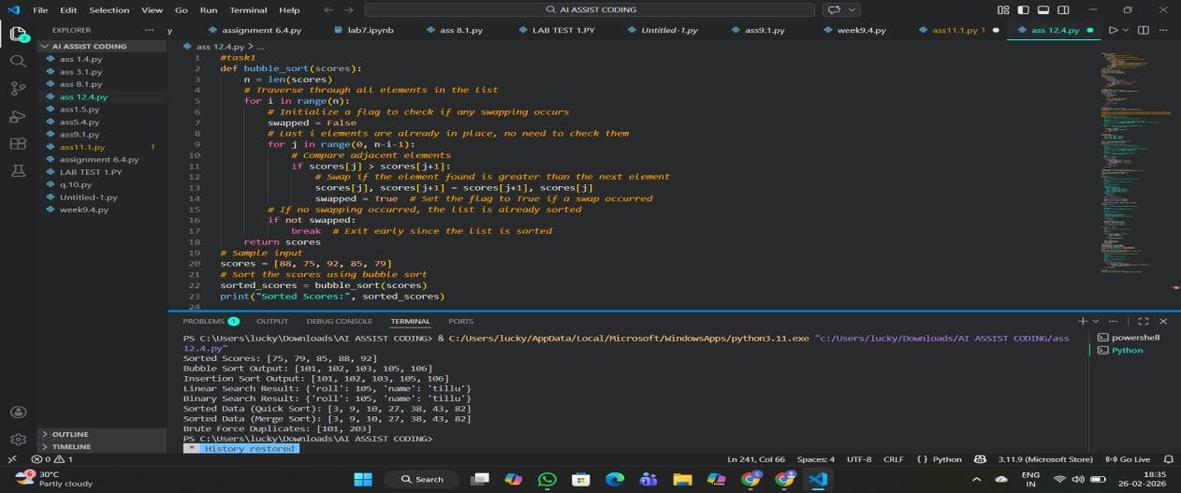
Output:


Observation:
The AI-generated Bubble Sort implementation correctly sorts student scores in ascending order.
The inline comments clearly explain comparisons, swaps, and iteration passes. The inclusion of an early-termination condition improves efficiency when the input list is already sorted or nearly sorted.
The provided time complexity analysis accurately reflects the algorithm’s performance characteristics.
Task:02
Task Description
- Start with a Bubble Sort implementation.
- Ask AI to: o Review the problem and suggest a more suitable sorting algorithm
o Generate an Insertion Sort implementation o Explain why Insertion Sort performs better on nearly sorted data
- Compare execution behavior on nearly sorted input
Expected Outcome
- Two sorting implementations:
o Bubble Sort o
Insertion Sort
- AI-assisted explanation highlighting efficiency differences for partially sorted datasets
Task 3: Searching Student Records in a
Database
Scenario
You are developing a student information portal where users search for student records by roll number.
Task Description
- Implement:
o Linear Search for unsorted student data Prompt:
Implement the insertion sort for the and compare with bubble which is more faster Code:
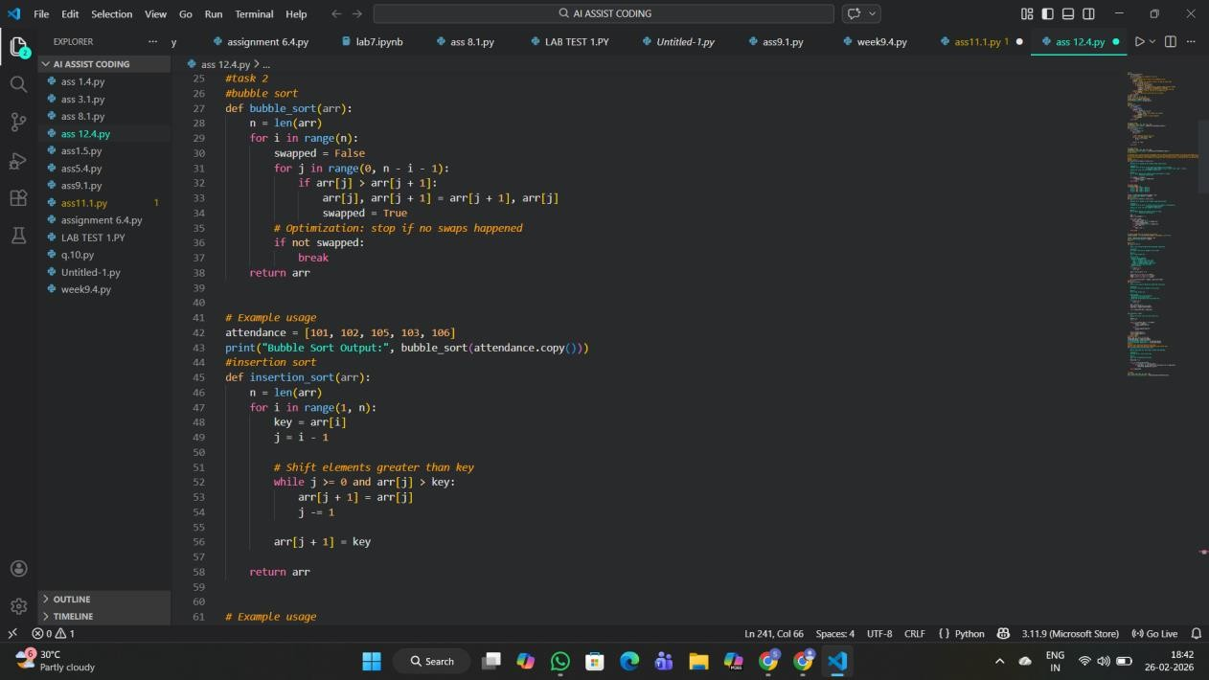
Output:

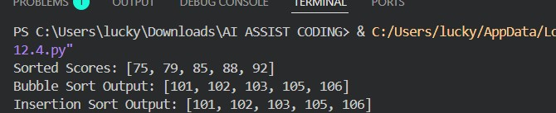
Observation:
For an attendance system where roll numbers are almost sorted, Insertion Sort is more efficient than Bubble Sort. It minimizes unnecessary comparisons and performs only the required shifts to place late entries correctly. Therefore, Insertion Sort is the preferred algorithm for maintaining partially sorted datasets Task:03
Scenario
You are developing a student information portal where users search for student records by roll number.
Task Description
- Implement: o Linear Search for unsorted student data o Binary Search for sorted student data
- Use AI to:
- Add docstrings explaining parameters and return values
- Explain when Binary Search is applicable o Highlight performance differences between the two searches
Expected Outcome
- Two working search implementations with docstrings
- AI-generated explanation of:
- Time complexity
- Use cases for Linear vs Binary Search
  - A short student observation comparing results on sorted vs unsorted lists
Prompt:
Implement the binary search and linear search compare the results Code:
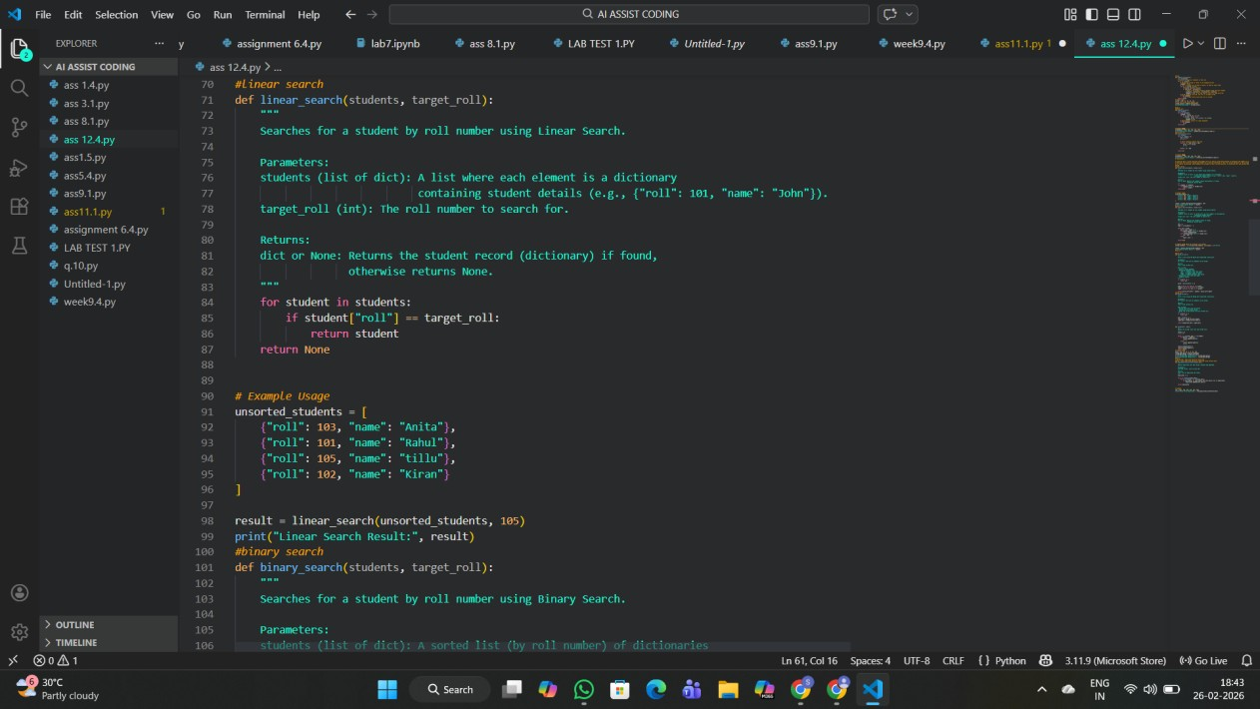
Output:
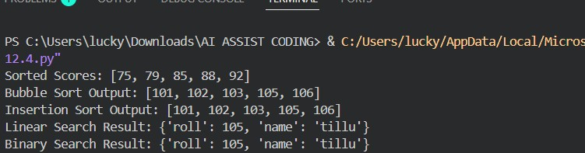
Observation:
Linear Search
  - Best Case: O(1) (first element)
  - Average Case: O(n)
  - Worst Case: O(n) (last or not found)
Binary Search
  - Best Case: O(1) (middle element)
  - Average Case: O(log n)
  - Worst Case: O(log n)
Linear Search successfully retrieves student records from an unsorted dataset by checking each entry sequentially. Binary Search, however, requires the data to be sorted but performs significantly faster by repeatedly dividing the search space in half. Experimental comparison shows that Binary Search is more efficient for large, sorted datasets, while Linear Search is more flexible for unsorted data.
Task:04
Scenario
You are part of a data analytics team that needs to sort large datasets received from different sources (random order, already sorted, and reverse sorted).
Task Description
• Provide AI with partially written recursive functions for:
- Quick Sort o Merge Sort • Ask AI to:
- Complete the recursive logic o Add meaningful docstrings
- Explain how recursion works in each algorithm
• Test both algorithms on:
o Random data o
Sorted data o
Reverse-sorted data
Expected Outcome
- Fully functional Quick Sort and Merge Sort implementations
- AI-generated comparison covering:
- Best, average, and worst-case complexities
- Practical scenarios where one algorithm is preferred over the other
Promot:implement the merge and qucik sort to my requrirements Code:
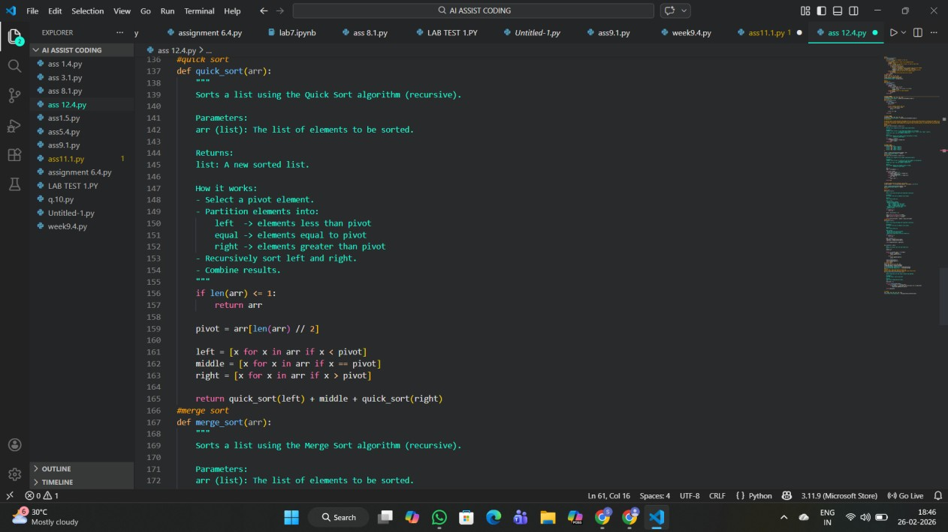

Output:
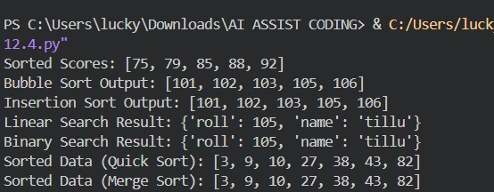
Observation:
Both Quick Sort and Merge Sort use recursion and divide-and-conquer strategies. Quick Sort is generally faster in practice due to lower memory overhead but can degrade to O(n²) on unfavorable inputs. Merge Sort guarantees O(n log n) performance regardless of input order and is preferred for large or stable sorting requirements.
Task:05
Scenario
You are building a data validation module that must detect duplicate user IDs in a large dataset before importing it into a system.
Task Description
- Write a naive duplicate detection algorithm using nested loops.
- Use AI to:
- Analyze the time complexity
- Suggest an optimized approach using sets or dictionaries o Rewrite
the algorithm with improved efficiency
- Compare execution behavior conceptually for large input sizes
Expected Outcome
- Two versions of the algorithm:
o Brute-force (O(n²)) o
Optimized (O(n))
• AI-assisted explanation showing how and why performance
Improved
Prompt:implement the navie duplicate detection Code
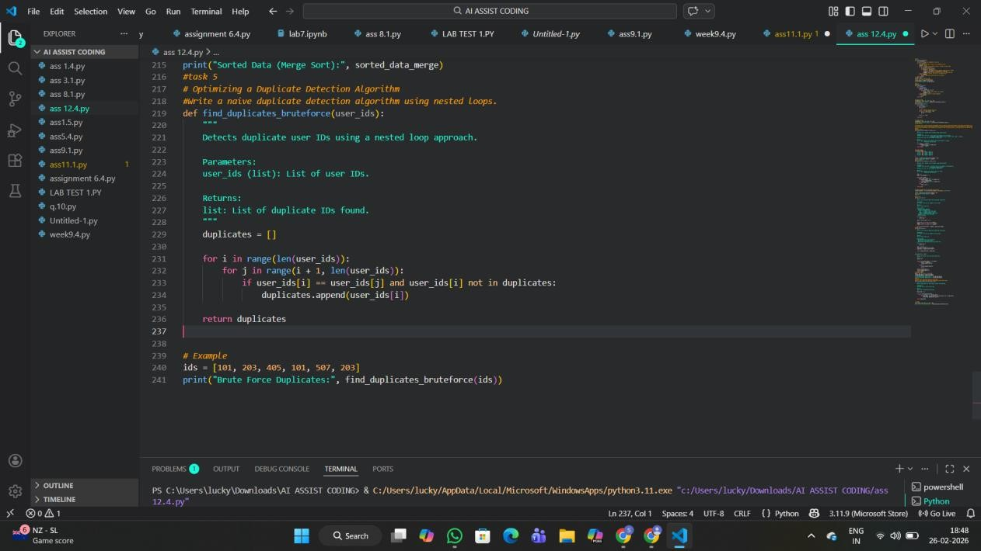
Output:
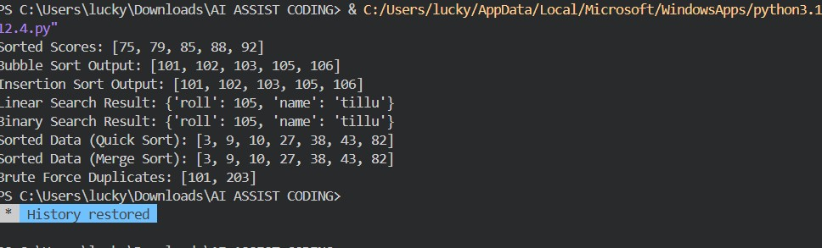
Optimized code:
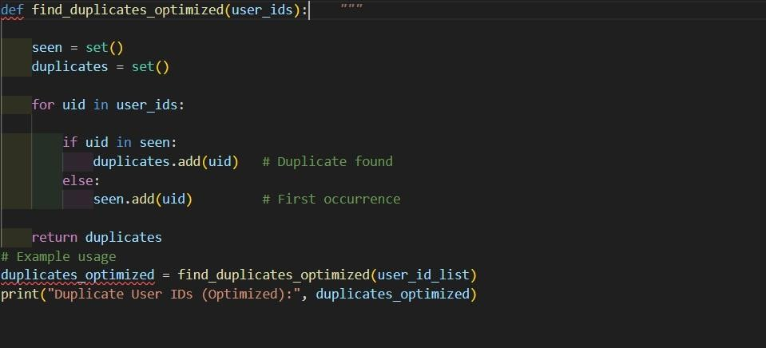
Observation:
The brute-force approach detects duplicates by comparing every pair of elements, resulting in O(n²) time complexity, which becomes impractical for large datasets. The optimized solution uses a set to track previously seen IDs, allowing duplicates to be identified in constant time per element. This reduces the overall complexity to O(n), making it suitable for large-scale data validation tasks.

